**Automated Testing**Automated Testing is the practice of writing code to test the code then run those tests in automated test. In contrast to manual testing where we manually click and test through the app

**Code = Production Code + Test Code**

**Types of Automated Tests  
Unit Tests  
Integration Tests  
End To End Tests**

**Unit Tests: -** Test a unit of application without its external dependencies such as files, databases etc. very fast to execute

**Integration Tests: -** Test the application with its external dependencies. It tests the integration of your code with external dependencies. Such as integration with database. Takes Longer to execute

**End To End Tests: -** Drives an application through its UI. Check the User Interface by mimicking User interaction. Very slow

**Unit Testing With Jest**

To Write Test with Jest You need to create a file with name of your file.test.js for example if your code file is code.js then the test file should be code.test.js

Import the code file in test file

To run Jest Test Go to Package.json file and add a test script

  "scripts": {

    "test": "jest"

  },

Example of testing a sum function

sum.js file

function sum(a, b) {

  return a + b

}

module.exports = sum

sum.test.js file

const sum = require('./sum')

test('add 1+2 equals to 3', () => {

  expect(sum(2, 2)).toBeGreaterThan(3)

  expect(sum(2, 2)).toBeGreaterThanOrEqual(3.5)

  expect(sum(2, 2)).toBeLessThan(5)

  expect(sum(2, 2)).toBeLessThanOrEqual(4.5)

})

To write define a test function that takes a description of the test and and a callback function. In which you call except function and pass the function with input you want to call. This test used expect and different matchers to test the conditions. These chain function are called matchers and they match the output of the function called to your expected output.

For example toBeGreaterThan matches the output 4 should be greater than expected output 3

**Testing Numbers With Jest**

Test cases for one function can be grouped together using describe statement and test statement can also be replace by it statement. For Example

module.exports.absolute = function (number) {

  return number >= 0 ? number : -number

}

describe('absolute', () => {

  it('should return a positive number if input is positive', () => {

    const result = lib.absolute(1)

    expect(result).toBe(1)

  })

  it('should return a positive number if input is negative', () => {

    const result = lib.absolute(-1)

    expect(result).toBe(1)

  })

  it('should return a 0 if input is 0', () => {

    const result = lib.absolute(0)

    expect(result).toBe(0)

  })

})

These following matchers can be used with Numbers

  toBeGreaterThan()

  toBeGreaterThanOrEqual()

  toBeLessThan()

  toBeLessThanOrEqual()  
 ToBe()

**Testing String With Jest**

ToBe() can also be used to match string but it will match exact but if you want to match just a specific substring should be there in string then toMatch(//) can be used that use regex or toContain() can be used

module.exports.greet = function (name) {

  return `Welcome ${name}`

}

describe('greet', () => {

  it('should return a greeting message', () => {

    expect(lib.greet('rishabh')).toMatch(/rishabh/)

  })

})

test checks for if greet message have rishabh in it

**Testing Arrays With Jest**

module.exports.getCurrencies = function () {

  return ['USD', 'AUD', 'EUR']

}

describe('getCurrencies', () => {

  it('should return supported currencies', () => {

    const result = lib.getCurrencies()

    expect(result).toEqual(expect.arrayContaining(['EUR', 'USD', 'AUD']))

  }

Matches returning array should contain these currencies if there are other currencies added the test won’t break

**Testing Objects With Jest**

*// Testing objects*

module.exports.getProduct = function (productId) {

  return { id: productId, price: 10, name: 'Soap' }

}

describe('getProduct', () => {

  it('should return product with given id', () => {

    const result = lib.getProduct(1)

    expect(result).toMatchObject({ id: 1, price: 10 })

  })

})

toBe should not be used when testing objects because it compare memory location of object which is going to going to be different for each object created. toMatchObject or toEqual should be used.

However to equal will throw an error if there are extra properties to the object. So that’s why in above example toMatchObject is used.

**Testing Exceptions With Jest**

*// Testing exceptions*

module.exports.registerUser = function (username) {

  if (!username) throw new Error('Username is required.')

  return { id: new Date().getTime(), username: username }

}

describe('register User', () => {

  it('should throw if username is falsy', () => {

    const args = [null, undefined, NaN, 0, '', false]

    args.forEach((a) => {

      expect(() => {

        lib.registerUser(a)

      }).toThrow()

    })

  })

  it('should return user object if valid user name is passed', () => {

    const result = lib.registerUser('rishabh')

    expect(result).toMatchObject({ username: 'rishabh' })

    expect(result.id).toBeGreaterThan(0)

  })

})

Note: the function that is going to throw exception should not be passed directly to expect like this expect(lib.registerUser(a)).toThrow() it will throw an error it should be passed in a callback like above example.

Testing for two path first that for non valid values. Register function should throw an exception and for valid input passed object should be returned with username and id should be a positive number

**Mocking functions**

When we are testing are code w we might find a code where function calls another function or external dependency. For unit testing we should not worry about these things we just want to test our individual functions not their interaction with others components. So we mock these functions and dependencies to continue testing.

We can manually mock them by replacing their implementation but jest comes with helper functions for mocking node module and functions

**Manually Mocking function example**

module.exports.applyDiscount = function (order) {

  const customer = db.getCustomerSync(order.customerId)

  if (customer.points > 10) order.totalPrice *= 0.9

}

applyDiscount depends on external db dependency to get customer

describe('applyDiscount', () => {

  it('should apply 10% discount if customer has more than 10 points', () => {

    db.getCustomerSync = function (customerId) {

*// console.log('fake reading customer...')*

      return { id: customerId, points: 20 }

    }

    const order = { customerId: 1, totalPrice: 10 }

    lib.applyDiscount(order)

    expect(order.totalPrice).toBe(9)

  })

})

Here we are manually replacing db.getCustomerSync implementation

**Mocking functions using Jest example**

*// Mock functions*

module.exports.notifyCustomer = function (order) {

  const customer = db.getCustomerSync(order.customerId)

  mail.send(customer.email, 'Your order was placed successfully.')

}

describe('notifyCustomer', () => {

  it('should send and email to the customer', () => {

    db.getCustomerSync = jest.fn().mockReturnValue({ email: 'a' })

    mail.send = jest.fn()

    lib.notifyCustomer({ customerId: 1 })

    expect(mail.send).toHaveBeenCalled()

    expect(mail.send.mock.calls[0][0]).toBe('a')

    expect(mail.send.mock.calls[0][1]).toMatch(/order/)

  })

})

Jest.fn mocks a function and we can chain mockReturnValue to return value

If we want to check if function has been called we can use toHaveBeenCalled method

We can also check if method is called with proper argument using mockFuntionName.mock.calls where first index specify call and second argument positon

And our we are testing our mail mock function should be called with a as first arg and second arg should contain order word in it

**Mocking Node Modules using Jest example**

const axios = require('axios')

const getUsersList = *async* () => {

  const response = await axios.get('https://jsonplaceholder.typicode.com/users')

  return response.data

}

module.exports = getUsersList

const axios = require('axios')

const getUsersList = require('./users')

jest.mock('axios')

*//mocking resolved values*

describe('getUsersList', () => {

  it('should return array of users objects', () => {

    const users = [

      {

        id: 10,

        name: 'Clementina DuBuque',

        username: 'Moriah.Stanton',

        email: 'Rey.Padberg@karina.biz',

      },

    ]

    const response = { data: users }

    axios.get.mockResolvedValue(response)

    getUsersList().then((data) => expect(data).toEqual(users))

  })

We use jest.mock function to mock modules here we are mocking axios.get method to return promised mockResolvedValue returns promise then we are using .then to process promise

**Jest Resolve Methods**

**mockReturnValue:- returns simple value**

**mockResolvedValue:- resolves a promise with value then you attach then or await to get value**

**mockRejectedValue:– reject a promise with value use exception handing to catch the exception thrown by mockRejectedValue**

**Link to read more:** [**https://jestjs.io/docs/en/mock-function-api**](https://jestjs.io/docs/en/mock-function-api%20)

**Mocking ES6 Classes**

const axios = require('axios')

class PostClient {

*async* getById(id) {

    const url = `https://jsonplaceholder.typicode.com/posts/${id}`

    const response = await axios.get(url)

    return response.data

  }

}

module.exports = PostClient

const PostClient = require('./PostClient')

class PostManager {

*async* getPostToManage(id) {

    const postClient = new PostClient()

    const postToManage = await postClient.getById(id).catch((err) => alert(err))

    return postToManage

  }

}

module.exports = PostManager

const PostManager = require('./PostManager')

const PostClient = require('./PostClient')

jest.mock('./PostClient')

describe('PostManager', () => {

  it('should return the post to the given id', *async* () => {

    const expectedResult = {

      userId: 4,

      id: 35,

      title: 'id nihil consequatur molestias animi provident',

      body:

        'nisi error delectus possimus ut eligendi vitae\nplaceat eos harum cupiditate facilis reprehenderit voluptatem beatae\nmodi ducimus quo illum voluptas eligendi\net nobis quia fugit',

    }

    const mockGetById = jest.fn()

    PostClient.prototype.getById = mockGetById

    mockGetById.mockReturnValue(Promise.resolve(expectedResult))

    const postManager = new PostManager()

    const result = await postManager.getPostToManage(35)

    expect(result.id).toBe(35)

  })

})

**Link:** [**https://dev.to/jackcaldwell/mocking-es6-class-methods-with-jest-bd7**](https://dev.to/jackcaldwell/mocking-es6-class-methods-with-jest-bd7)

**Integration Testing With Jest**

Integration testing is where we test interaction between different components like external dependencies databases and such. To Do Interaction testing with jest we use a library called supertest

Supertest is a library that helps to test API endpoints. It’s a http testing library

**How to use Supertest with Jest**

Install it npm install supertest or yarn add supertest.

To use supertest it need a reference to http server running so export your server variable like this

const winston = require('winston')

const express = require('express')

const app = express()

require('./startup/logging')()

require('./startup/routes')(app)

require('./startup/db')()

require('./startup/config')()

require('./startup/validation')()

const port = process.env.PORT || 3000

const server = app.listen(port, () =>

  winston.info(`Listening on port ${port}...`)

)

module.exports = server

Now we can use this exported server variable to do test using super test

**Note:- Server should be closed after testing each call otherwise it will throw and error saying port is already in use. Below example will show this**

const request = require('supertest')

const { Genre } = require('../../models/genre')

const { User } = require('../../models/user')

let server

describe('/api/genres', () => {

  beforeEach(() => {

    server = require('../../index')

  })

  afterEach(*async* () => {

    server.close()

    await Genre.remove({})

  })

  describe('GET /', () => {

    it('should return all genres', *async* () => {

      await Genre.collection.insertMany([

        {

          name: 'genre1',

        },

        {

          name: 'genre2',

        },

      ])

      const res = await request(server).get('/api/genres')

      expect(res.status).toBe(200)

      expect(res.body.some((g) => g.name === 'genre1')).toBeTruthy()

      expect(res.body.some((g) => g.name === 'genre2')).toBeTruthy()

    })

  })

  describe('GET /:id', () => {

    it('should return a genre if valid id is passed', *async* () => {

      const genre = new Genre({ name: 'genre1' })

      await genre.save()

      const res = await request(server).get(`/api/genres/${genre._id}`)

      expect(res.status).toBe(200)

*//should not use match object because id returned is string and what we are saving is object id*

      expect(res.body).toHaveProperty('name', genre.name)

    })

    it('should return 404 if invalid id is passed', *async* () => {

      const res = await request(server).get('/api/genres/1')

      expect(res.status).toBe(404)

    })

  })

  describe('POST /', () => {

    it('should return 401 if client is not logged in', *async* () => {

      const res = await request(server)

        .post('/api/genres')

        .send({ name: 'genre1' })

      expect(res.status).toBe(401)

    })

    it('should return 400 if genre is less than 5 characters', *async* () => {

      const token = new User().generateAuthToken()

      const res = await request(server)

        .post('/api/genres')

        .set('x-auth-token', token)

        .send({ name: '1234' })

      expect(res.status).toBe(400)

    })

    it('should return 400 if genre is more than 50 characters', *async* () => {

      const token = new User().generateAuthToken()

      const name = new Array(52).join('a')

      const res = await request(server)

        .post('/api/genres')

        .set('x-auth-token', token)

        .send({ name: name })

      expect(res.status).toBe(400)

    })

    it('should save the genre if it is valid', *async* () => {

      const token = new User().generateAuthToken()

      const res = await request(server)

        .post('/api/genres')

        .set('x-auth-token', token)

        .send({ name: 'genre1 ' })

      const genre = await Genre.find({ name: 'genre1' })

      expect(genre).not.toBeNull()

    })

    it('should return the genre if it is valid', *async* () => {

      const token = new User().generateAuthToken()

      const res = await request(server)

        .post('/api/genres')

        .set('x-auth-token', token)

        .send({ name: 'genre1' })

      expect(res.body).toHaveProperty('_id')

      expect(res.body).toHaveProperty('name', 'genre1')

    })

  })

})

BeforeEach and afterEach are special functions which are called after each test call we will use it to import our server and afterEach will do all clean up stuff. If we don’t close the server error will be thrown so in afterEach server.close() is used and close we are deleting all the insertion made in database. So our tests does not behave weirdly

In this example

We have one parent describe block where we give the description of the endpoint we are testing

Example: describe (‘/api/movies’, () =>{})

Which contain all the different test suits for different http verbs like GET, POST, PUT, DELETE

The first child describe (‘GET /’) block contains all the tests for the get request using it statements. Same goes for other http verb

Server variable is being passed to request function when we call it with any get post put or delete method and then we make assertion for the response returned from the call

**SuperTest methods explained**

1. get, post, delete, put methods correspond to the action we performing it takes route as a parameter

2. set method is used to set headers for request. In above example we are setting x-auth-token header that contains authentication token

3. send method sends the data with request

**Tip: To continuously running jest you can pass –watch all flag in package.json**

  "scripts": {

    "test": "jest --watchAll --verbose"

  },

**--verbose flag is used here so output of jest will show longer messages when testing**

**Code Files Link:** [**https://github.com/rishabhchoudhary2496/testingPracticeFiles**](https://github.com/rishabhchoudhary2496/testingPracticeFiles)

**Note: Sometimes we face an error for port already in use error even if we close it in afterEach. It happens because jest runs test parallelly. To fix that add flag –maxWorkers=1**

  "scripts": {

    "test": "jest --watchAll --verbose --maxWorkers=1 --coverage"

  },

We are using User.generateAuthToken for protected routes which need authentication

Set method with supertest can be used to set headers

**Code Coverage Jest**

Code Coverage is a measurement that tells us how much of our code is covered under tests.

It is good metric to have to see which code is remaining uncovered. To use code coverage with jest. Add –coverage flag in script test

  "scripts": {

    "test": "jest --watchAll --verbose --maxWorkers=1 --coverage"

  },

Restart the test by ctrl+c and running npm test again now it will show a table of code coverage below in terminal. But to get a better view see a folder called coverage will be generated in your current path. Go to that folder it will contain a folder with report in name. go to that folder and open index.html file. It will all things related to code coverage

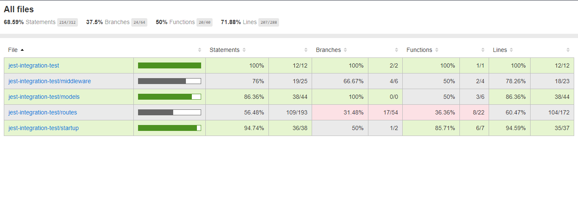

It will show like these for different folders with different stats you can go inside them and open individual files

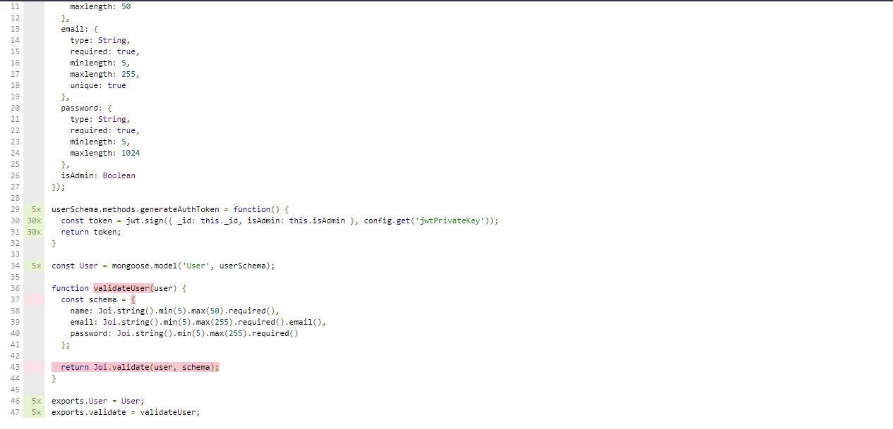

It will show the lines marked red which are not covered currently and above it will also show the percentage of test covering the file.

Code coverage is nice tool to have to see which code remained to be covered to be tested